Meet the Y6 staff

6L: 6R:
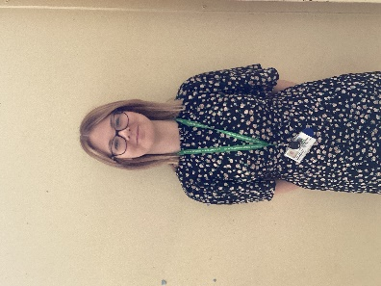
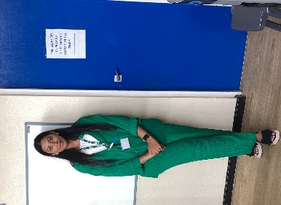
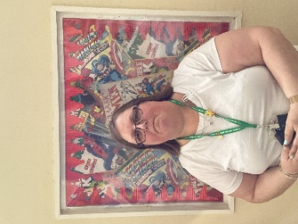
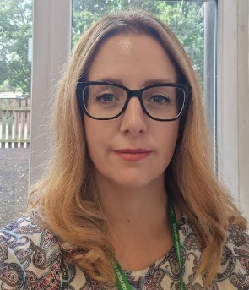
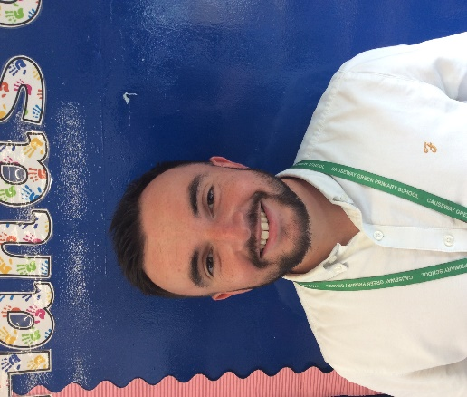
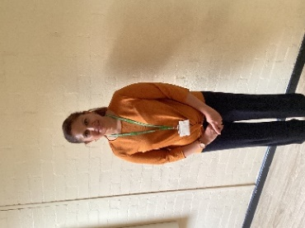
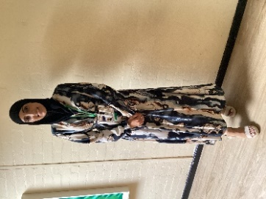

Miss Begum
LSA
Miss Ridley
LSA
Miss Rahman
LSA
Mrs Cole
HLTA
Mr Hinton
Class Teacher
Miss Bibi
HLTA
Miss Mullett
Class teacher

List 1 | List 2 | List 3 | List 4 | List 5 | List 6 | List 7
Personalised spellings within the year group. | Personalised spellings within the year group. | Horrible  Terrible  Disposable  Forgivable  Legible  Reversible  Enjoyable  Respectably  Agreeably  Identifiable | Refer  Referring  Reference  Referral  Prefer  Preferring  Preference  Transfer  Transferal  transferring | Deceive  Conceive  Receive  Mischief  Retrieve  Achieve  Height  Ceiling  Receipt  Neither | Frequently  Mischievous  Pronunciation  Stomach  According  Committee  Dictionary  Government  Muscle  Queue | Personalised spellings within the year group.
List 8 | List 9 | List 10 | List 11 | List 12 | List 13 | List 14
Personalised spellings within the year group. | Advice  Advise  Device  Devise  Practice  Practise  Licence  License  Prophecy  Prophesy | Sufficient  Achieve  Communicate  Disastrous  Guarantee  Necessary  Recognise  Suggest  Aggressive  Community | Vicious  Delicious  Cautious  Conscious  Precious  Nutritious  Infectious  Ambitious  Fictitious  Suspicious | Embarrass  Harass  Neighbour  Recommend  Symbol  Amateur  Competition  Environment  Hindrance  Nuisance | Relevant  System  Ancient  Conscience  Equipment  Identity  Occupy  Restaurant  Temperature  Apparent | Personalised spellings within the year group.

Year 6
Evolving Egyptians

Key information
- Stunning start – Creating our own museum
- Fantastic finish – Sculpting Clay Scarab Beetles (To be confirmed).
- PE - The topic this term is health related fitness, Dance and Gymnastics.
- Homework – CGP books, reading, spellings, Pobble writing
Maths
At the start of the term, our main focus will be on number and place value, addition, subtraction, multiplication, division and Fractions. At the end of Autumn term, we will also focus on converting units.
Activities to support learning can be carried out using the CGP books that will be used for homework as well as ‘Learning with Parents’ and TTRS- logins will be sent out
Science
This term’s topics include light and electricity and the children will be focusing on learning about how to carry out a fair test and exploring light and how it travels. We will also investigate how we see objects by light entering the eye and the children will also experiment with electricity and circuits.

English
The children will be producing writing using a selection of materials from their whole class texts: letters, narratives and explanation texts. They will identify key features of the text and develop an understanding of its purpose.
Also, they will be reading ‘The boy at the back of the class’ discussing the details of the story. Using this text, the children will write a setting description, a detailed character description and an informal letter from a character’s perspective.

What can you do at home to help?
- Listen and encourage your child to read at home three times a week record this on learning with parents
- We will have a weekly spelling test on a Tuesday. Please ensure your child is practising the week’s spellings (found on the first page of this newsletter) for that week.
- As this year is SATs year, it would be beneficial to support the children in learning their times tables and doing extra work at home. However, please do not use any past SATs papers as we use these in school!
- Complete your pobble writing!

How long ago and how far away?
History and Geography
We will be introducing the topic of Ancient Civilisations this term, where the children will explore Ancient Egypt. The children will develop their sense of chronology and time, whilst investigating the achievements of this civilisation and how their achievements have impacted the world and modern-day life.
The children will be learning about physical impact within our world including: fires, droughts and pollution. The children will complete case studies on different parts of the world identifying how global warming is causing an impact to different people.

