Meet the Y4 staff

4L: 4R:
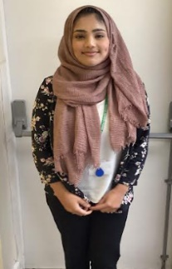
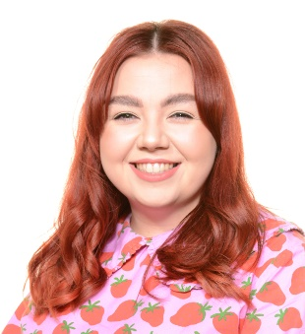
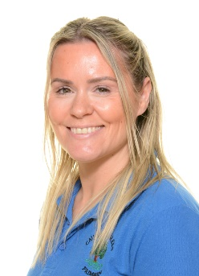
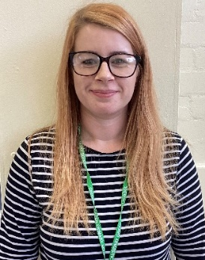

Miss Sly
Class teacher
Mrs Tozer
LSP
Mrs Lowe
LSP
Mrs Hussain
Class teacher

List 1 | List 2 | List 3 | List 4 | List 5 | List 6 | List 7
Pressure  Treasure  Measure  Pleasure  Closure  Enclosure  Leisure  Composure  History  Library | Therefore  Possible  Circle  Believe  Arrive  Ordinary  Woman  Thought  Natural  Group | Heard  Herd  Peace  Piece  Main  Mane  Fair  Fare  Knowledge  Decide | Island  Popular  Surprise  Enough  Consider  Breath  Accident  Occasion  Learn  Famous | Illegal  Illegible  Illiterate  Illogical  Inactive  Incapable  Incredible  Inaccurate  Interest  Increase | Impossible  Immature  Immobile  Impatient  Impolite  Irregular  Irrational  Irresponsible  Irresistible  Regular | Actual  Bicycle  Calendar  Describe  Early  Favourite  Grammar  Heart  Imagine  Length
List 8 | List 9 | List 10 | List 11 | List 12 | List 13 | List 14
Eight  Reign  Young  Touch  Brochure  Machine  Country  Weight  Grey  Chef | Material  Naughty  Occasionally  Particular  Quarter  Recent  Sentence  Though  Various  Women | Gardener  Preferred  Cornering  Fastened  Awaking  Beginning  Limited  Beginner  Forgetting  Positioning | Guide  Guitar  Guest  Guardian  Guard  Guarantee  Guess  Guidebook  Guilty  Gum | Mixture  Picture  Adventure  Capture  Feature  Moisture  Nature  Vulture  Creature  Puncture | Accidently  Breathe  Caught  Different  Exercise  February  Height  Important  Medicine  Notice | Scene  Seen  Bawl  Ball  Mail  Male  Question  Suppose  Perhaps  Complete
What can you do at home to help?
Hear your child read and record this on learning with parents. to ensure they are reading at least 3 times per week in order to achieve their Roarsome Reading award.
Encourage them to use Timetable Rock Stars to prepare them for the Multiplication Check at the end of Year 4.
Test them on their Year 4 spellings which are found in their spelling books.
Complete homework set on Learning with Parents and pobble writing .
Science
This term, we are looking at states of matter and living things and their habitats.
We will be exploring solids, liquids and gases and identifying their properties.
In the second half term, we will be looking at animals and where they live, our local area and environment issues.
Key information
- Stunning start – Archaeological dig/excavation.
- Fantastic finish – Clever Climates investigation.
- PE - Gymnastics and dance. Please send your child with their PE kit every Tuesday and Wednesday.
- Outdoor learning- Wreath making
- Homework- will be set every Thursday on Learning with Parents, Pobble writing will be set and shared in class
Anglo Saxons and Scots (Aut 1)
What can we unearth at Sutton Hoo?
DT/Art
Our DT project this term will be to research, plan and make bread, in order to do this, we will evaluate food products in terms of taste, smell, texture and appearance.
During Art we will be drawing on our knowledge of Clever Climates to create a landscape painting. We will compare other landscape artists such as Henri Rousseau and Georgia O’Keefe.
Humanities
During this term the children will be looking at the Anglo Saxons and their impact on Britain. We will look at:
• The reason for Romans leaving Britain
• Who the Anglo Saxons were and the groups of people that formed this community
• Identifying where and why the Anglos Saxons chose to settle in Britain.
• How the Anglo Saxon’s religion changed throughout their time period
• The Anglo Saxon burial site Sutton Hoo.

In the second half of the term, the children will be looking at climate change. They will observe, describe and explain climate in the UK and compare it to other parts of the world.

Clever Climates (Aut 2)
Why are jungles so wet and deserts so dry?
Maths
- This term our Maths will focus on enhancing and building the children’s mathematical skills through- number and place value, addition and subtraction, multiplication and division.
- The children will also be learning their multiplication tables daily up to 12x12 – Y4 will complete a statutory Multiplication Check in Summer term.
- We will continue to practice their mental maths through our maths assessments.
English
In English this term we will be focusing on our class text- The Iron Man by Ted Hughes.
The children will produce a variety of text types including non-chronological reports, newspaper articles, stories and descriptive writing. The foci for writing this term will be; fronted adverbials and using a range of different sentence openers such as time, manner and place. Our main focus will be extending our knowledge of clauses and introducing different sentence structures.

