Meet the Y3 staff

3L: 3R:
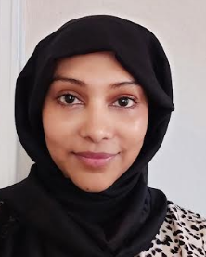
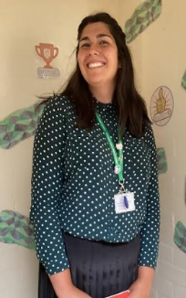
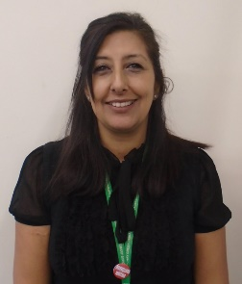

Miss Clewley
LSP
Miss Ahman
LSP
LSP
Mrs Dhariwal
Class teacher
Mrs McCartney
LSP
Mr Stokes
LSP
Mrs Begum
Cover teacher

Mrs O’Driscoll
Class teacher
List 1 | List 2 | List 3 | List 4 | List 5 | List 6 | List 7
walks  runs  searches  waves  reaches  bakes  plans  floats  claps  hopes | chatting  clapping  hoped  hoping  searcher  liking  smiling  planner  floater  baked | dislike  unkind  displeased  disappointed  unhappy  disagree  disobey  disappear  disbelieve  unzip | doesn’t  can’t  won’t  wouldn’t  couldn’t  shouldn’t  he’s  it’s  there’s  I’d | reign  rain  rein  vein  straight  baby  they  play  grape  complain | brake  break  grate  great  eight  ate  weight  wait  son  sun | surprise  recent  popular  natural  island  group  enough  consider  breath  accident
List 8 | List 9 | List 10 | List 11 | List 12 | List 13
recent  position  naughty  knowledge  guard  exercise  continue  breathe  accidentally  actual | weigh  way  sleigh  slay  plain  plane  made  maid  prey  pray | excitement  employment  enjoyment  document  statement  happiest  funniest  kindest  biggest  smallest | reappear  rebuild  rewrite  remember  reapply  mistake  mishear  miscalculate  misbehave  misread | gym  cygnet  pyramid  myth  mystery  Egypt  symbol  typical  crystal  lyric | fatigue  catalogue  league  tongue  therefore  though  although  guide  heard  learn
DT/Art
- Our Art project will explore the work of Andy Warhol. Our research and work in lessons will lead us to creating a pop art style volcano.

- In DT we will be creating our own money holders using felt. We will need to ensure our final product is fit for its purpose and audience.
Key information
- Stunning start – scavenger hunt looking for rocks/ soil
- Fantastic finish – visit to Sandwell Valley
- PE – Monday and Thursday
- Homework- will be set every Thursday on Learning with Parents. Pobble writing will be set and shared weekly.
Thematic
Geography (Autumn 1 focus)- Violent volcanoes.
- In our Geography lessons, we will be using our geographical skills to locate where volcanoes are on a map. We will also explore ‘the ring of fire’ and the significance of tectonic plates.
History (Autumn 2 focus)- Escape from Pompeii
- In History lessons, we will be looking at the events of the eruption of Mount Vesuvius. We will consider what people living in Pompeii at the time experienced and how they felt at the time.

Escape from Pompeii- Autumn 2
How was the town preserved?

Violent Volcanoes- Autumn 1
How do volcanoes affect the lives of people?

What can you do at home to help?
- Homework -Please complete work set on Learning with Parents. Regular use of our Learning with Parents website will help your child practise skills taught in school.
- Ensure your child is reading at least 3 times a week and record this on learning with parents. To help them further you could ask them questions about what they are reading.
- Practise the spellings on this newsletter. Your child will bring home their red spelling book with the spellings for each week.
- Practise handwriting, focussing on correct formation and joins.
- Complete homework tasks such as Pobble which will be sent out every Friday and collected in by Thursday the following week.

Maths
- This term in Maths we will focus on number. The units we will cover are place value, addition, subtraction, multiplication and division.
- The children will also be continuing to learn their multiplication tables.
- We will continue to practise their mental maths through our maths assessments.
- Activities to support learning will be set on www.ttrockstars.com and learning with parents.

English
- We will be writing a range of texts based around the book ‘Owen and the soldier’.
- Through this text, the children will be using a range of skills to create setting and character descriptions and a diary entry.
- We will also continue to focus on improving spelling, punctuation and grammar with a particular focus on spelling this term using our ‘PENPALS’ handwriting scheme.

