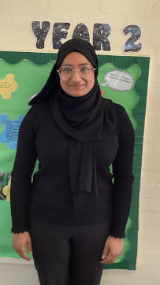
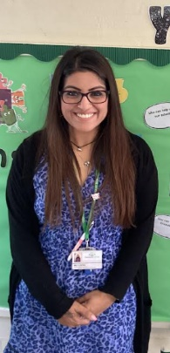
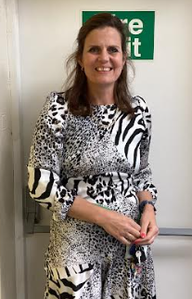
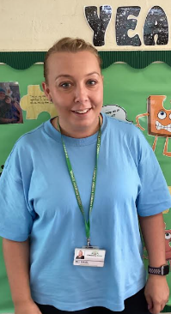
Meet the Y2 staff

Mrs Jarvis
2R Class Teacher
Mrs Abbotts
2L LSP
Miss Wahid
2L Class teacher
Mrs. Akhtar
2R LSP
List 1 | List 2 | List 3 | List 4 | List 5 | List 6 | List 7
see  sea  be  bee  grey  today  play  door  floor  poor | waste  frame  game  chase  bride  stripe  quite  mine  because  could | photo  elephant  dolphin  phone  whisker  whistle  whale  white  old  class | explode  code  whole  alone  cube  flute  huge  June  busy  should | find  kind  behind  mind  item  idea  final  pilot  iron  silent | eye  could  should  would  who  whole  any  many  clothes  plant | eight  straight  thumb  lamb  comb  bridge  badge  station  fiction  emotion
List 8 | List 9 | List 10 | List 11 | List 12 | List 13 | List 14
fast  last  past  toast  ghost  gold  hold  told  people  father | jacket  jar  jog  join  jig  giant  giraffe  gentleman  gem  gerbil | cage  rage  huge  change  age  badge  edge  dodge  fudge  hedge | face  ice  city  pencil  once  icy  cycle  circle  hour  parents | here  hear  son  one  won  blue  blew  too  two  to | knot  know  knee  knife  knit  gnome  knight  knew  sign  design | every  everybody  even  great  break  steak  pretty  beautiful  after  sure
DT/Art
- In art children will experiment with tone and colour mixing to produce a piece of work in the style of Tinga Tinga Art.

- Linked with their work on animals in their humanities topic, children will be designing and making their very own wild animal finger puppet.
Remember Me (Autumn 1)
Florence Nightingale and Mary Seacole
Why is it important to remember?
Key information
- Stunning start – Escape room
- Fantastic finish – Safari Park trip
- PE - Please send your child in their PE kits on the following days:: 2L: Wed/Thur 2R: Thur/Fri
- Outdoor learning- Remembrance crafts
- Homework- will be set every Thursday on Learning with Parents and a weekly Pobble task will be set on Friday to be handed in the following Thursday.
English
This term our English lessons will be linked around a range of fiction and non-fiction books. Children will be completing a character description, retell, setting description and a fact file.
Key skills to help them improve their writing will be taught, including how to form different types of sentences (statement, question, command and exclamation).
We will be looking at techniques to extend sentences and how to add detail. During this they will learn about subordinating conjunctions (because, when, if, that), coordinating conjunctions (and, but, so, or) and expanded noun phrases.
Maths
- During this term we will focus on Place value, addition and subtraction and shape.
- We will be continuing to learn the recall of multiplication and division facts for 2, 5, 10 times tables during our fluency sessions and developing our mental strategies to add and subtract efficiently
- Activities to support learning can be carried out using www.ttrockstars.com- Logins will be sent home.
Thematic
History- Pupils will be taught about the lives of significant individuals in the past. This will lead to a study of the work of Florence Nightingale and Mary Seacole.
Geography- Pupils will be taught about the distribution of hot and cold places in the world and how living things have to adapt to survive in such places. By comparing a number of environments, pupils will be able to identify and describe similarities and differences between places in the world and offer reasons for why such differences exist.

What can you do at home to help?
- Homework -Please complete work set on Learning with Parents. Regular use of our Learning with Parents website will help your child practise skills taught in school.
- Ensure your child is reading at least 3 times a week and record this on Learning with Parents platform.. To help them further you could ask them questions about what they are reading.
- Practise the weekly spellings sent via the newsletter and displayed on classroom doors
- Practise handwriting focussing on correct formation
- You could test them on their YR2 common exception spellings which will be sent out.

Animals around the World (Autumn 2)
Why don’t penguins need to fly?

