**Meet the Y1 staff**

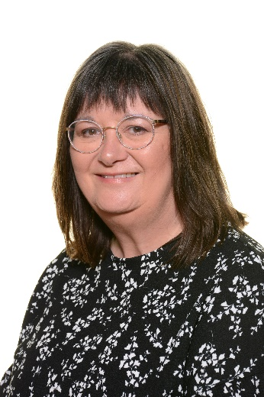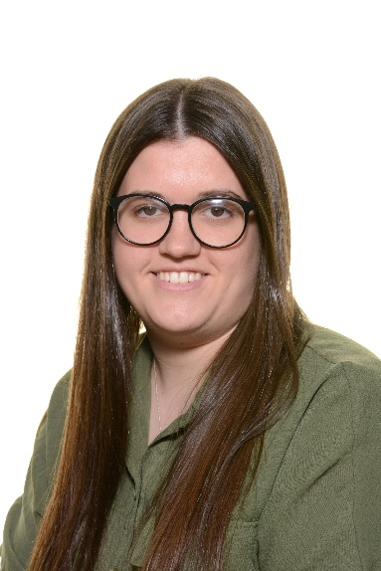***1L: 1R:***

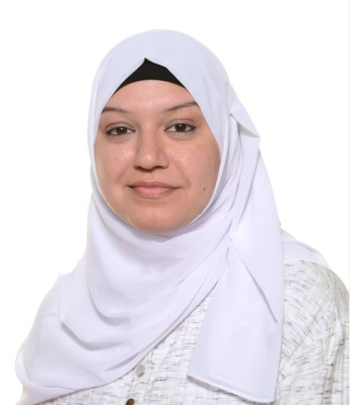

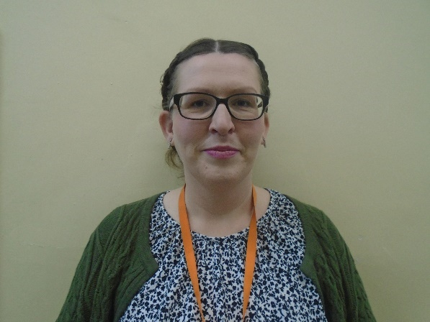

**Mrs Aktar**

**LSP**

**Mrs.Whitehouse**

**LSP**

**Mrs Bembow**

**Class teacher**

**Mrs.Doxford**

**Class teacher**

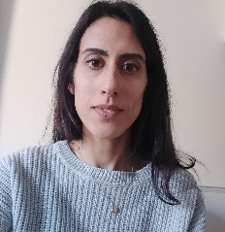

**Miss Johnson**

**1:1**

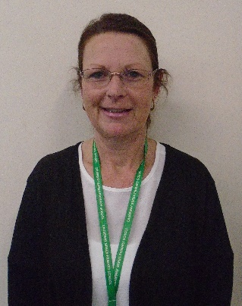



**Mrs. Binsley**

**1:1**

**Mr Cole**

**1:1**

**What can you do at home to help?**

* You could hear your child read and record this online.
* You could encourage them to be more independent and do more for themselves e.g. getting dressed, taking their jumper on and off and putting on their shoes.
* You could test them on their YR1 common exception spellings (Please ask if help is needed to find them)
* Complete homework set on Learning with Parents
* Complete weekly Pobble writing based on news/events they would like to share with the class e.g. what they did on the weekend, birthdays, days out.

**English**

* This term our English lessons will be linked around story books to engage the children. Our first topic will be based on the story book Lion King.
* Key skills to help them improve their writing will be taught, including how to form letters, reducing letter size and how to use capital letters and full stops.
* We will also be looking at techniques to order events within books we have read and to write sentences about these stories.

**What is the geography like where I live?**

**Key information**

* **Stunning start –** Local area all about me
* **Fantastic finish –** Making a guy Fawkes
* **PE –** 1L – Wednesday and Friday
* 1R –Tuesday and Friday
* **Homework -** Learning with Parents.
* **Trips –** we will be visiting the Gurdwara and the cinema.

**Marvellous Me**

**Maths**

* During this term we will focus on basic skills including counting forwards and backwards to 100, number bonds to 10 including related subtraction and finding half of numbers and shapes.
* During our shape and measure topic we will be recognising and naming common 2D shapes.
* We will be learning to count and recall in multiples of 2, 5 and 10 and to double and halve numbers to 20.

**Science**

* During this term, children will be looking at the topic Animals including Humans.
* Children will identify body parts of animals and classify and categorise animals in different ways.

**DT/Art**

* In Art children will experiment with tone and using colour to indicate mood in the style of the artist Pablo Picasso.
* In DT at Christmas, children will be making Christmas cards with moving parts involving mechanisms.

**History and Geography**

* Linked with science, our Geography topic will cover learning all about themselves. This will include knowing where they come from and how to locate where they live on a map.
* This term in History children will be learning about Guy Fawkes and the gunpowder plot. They will also learn how historical events effect how we live now.