**Phonics**

Children will be taught phonics through daily sessions, using the Little Wandle scheme. This will help children to hear phonemes in words and recognise the graphemes that represent them.

**You’ve Got a Friend in Me / Sparkles and Celebrations**

**Understanding the World**

We will be learning how to stay safe online.

In Science, we will be finding out about our bodies and naming basic body parts through songs and games.

The children will also explore and discuss their own families and family history.

**Physical Development**

Children will be looking at the differences in their bodies when they do physical activities.

We will be looking at hand washing and taking care of ourselves to keep healthy during snack and toilet times and when getting ready for lunch.

**Communication, Language and Literacy**

Children will be working in both large and small groups to share ideas and stories. We will be using a wide range of high quality stories to help children develop a love of reading. Through our topic, ‘You’ve Got A Friend in Me’ the children will have the opportunity to share and record from their own experiences and use role play to help them re-tell stories.

Our class text will be ‘Owl Babies’ to help the children with their transition to Reception.

**Key information**

We have planned exciting themed weeks to support transition in the Autumn term! Including- Arts week and Happy, Healthy Me week!

* **Stunning start –** Animal visit
* **Fantastic finish –** We shall visit a local church
* **PE – Thursday** remember to arrive at school in PE kit.
* **Homework –**Homework will be set weekly on our homework service- Learning with Parents.
* **Trips/Experience-**Animal visitor to school, Church trip
* **Weather –** We will go outside in all-weather so please send your child prepared for this!
* **Reception Fund –** Please remember to pay you £1 weekly reception fund to your class teacher every Monday.

**Reception Autumn 23**

**Maths**

Children will be using a wide range of number songs and rhymes to recognise and use numbers to 10. They will be using lots of practical activities and equipment to help them link maths to the real world. The children will also take part in maths investigations, enabling them to practise their problem solving and reasoning skills.

**What can you do at home to help?**

* Hear your child read and record this on Learning with Parents. To help them further you could ask them questions about what they are reading.
* Complete homework set on Learning with Parents.
* Take your child to the local library.
* Share books together – these can also be recorded on Learning with Parents. Remember to talk about what is happening in the books, what might happen, locate the author’s/illustrator’s name and the title.
* Practice writing their full name.
* Try to include maths as you go about daily routines. You could talk about shapes in the environment, count items as you do the shopping, weigh ingredients as you are cooking.

**Expressive Art & Design**

We shall be using the theme of ‘You’ve Got a Friend in Me’ to explore similarities and difference. We shall be painting self-portraits. Later in the term, we shall be making clay divas and decorating them with pattern as we celebrate Diwali. In December we shall use our creative skills as we get ready to celebrate Christmas. We shall also look at different artists and explore how they make art.

**Personal Social and Emotional Development**

Children will be taking part in a range of circle time activities to get to know their new school friends and teachers. We shall also be following a new scheme of work called ‘Jigsaw’ to support our PSED understanding.

We will be focusing on working together and taking care of ourselves and others. We will be learning to use our belongings and equipment in the classroom with care. Alongside this, we will be introducing our class rights and responsibilities to help us to make positive choices.

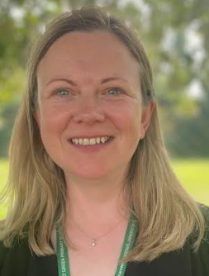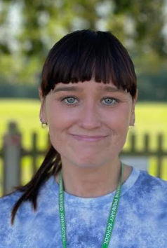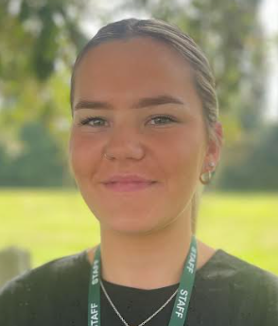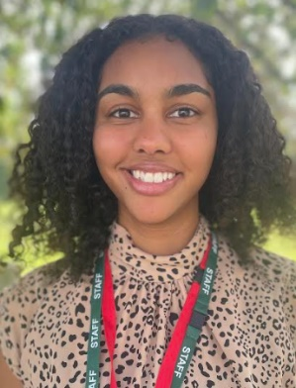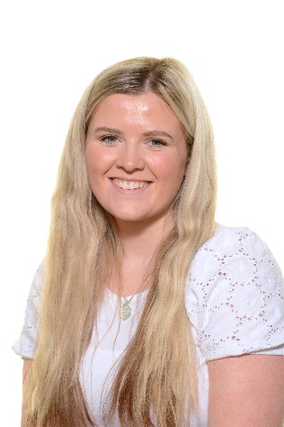 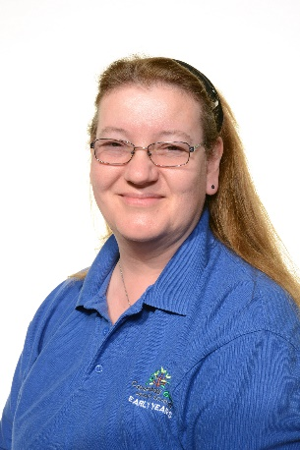

**Miss Turton**

**LSA R2**

**Miss Cunningham**

**LSP R2**

**Miss Russell Lacy**

**Class teacher R2**

**Miss Wilson**

**LSA R1**

**Mrs Stewart**

**LSP R1**

**Miss Blackwell**

**Class teacher R1**

**Meet the Reception staff**

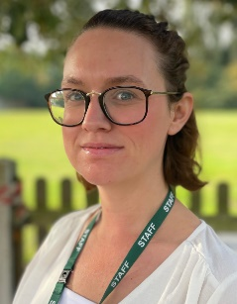

**Miss Willetts**

**LSA R2**

**Banksy**

**School dog**