**Meet the Nursery staff**

 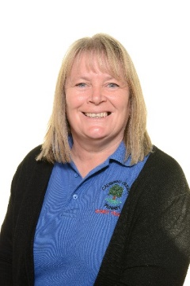   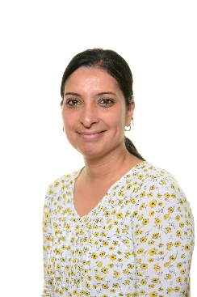

**Miss Assi**

**1:1 Support**

**Mrs. Hodgetts**

**Nursery Assistant**

**Mrs. Hems**

**LSP**

**Mrs. Hartland**

**LSP**

**Mr. Clayton**

**Early Years Leader**

**Key information**

* **Stunning start –** World Nursery Rhyme Week – children will dress as their favourite nursery rhyme
* **Fantastic finish –** Visit to see Santa!
* **PE –** Monday AM and Tuesday PM remember to wear sportswear
* **Homework –** This will be set on Learning with Parents every Monday
* **Trips –** We will be visiting Dudley Zoo for our Christmas trip. More details to follow!
* **Weather –** We will go outside in all-weather so please send your child prepared for this!
* **Nursery Fund –** Please remember to pay your £! weekly nursery fund to a member of staff

**Maths**

Part of our maths work will be getting used to our routines and learning about what happens at certain times of the day. We shall be going on a shape hunt around school getting to know the school as we search for different shapes. During our celebrations, we shall be counting sequins to decorate Divas and Santa will need lots of help during this busy period sorting presents by size in his Christmas workshop.

**What can you do at home to help?**

* Hear your child read and record this in their planner. To help them further you could ask them questions about what they are reading.
* Complete homework set on Learning with Parents.
* Use the following websites for fun learning activities:
* <http://www.sparkisland.com/>
* <https://www.littlewandlelettersandsounds.org.uk/resources/for-parents/>
* <https://causeway.sch.life/>

**Expressive Art & Design**

We shall be using the theme of we are family to get to know the children. This will include making self-portraits, sharing ideas of our favourite toys and foods whilst getting to know everyone.

Our People who help us topic will teach us about stranger danger and how we can stay safe in the season of celebrations. We shall also be getting creative as the Christmas season approaches.

**PSED**

Children will be taking part in a range of circle time activities to get to know their new school friends and teachers. We shall also be following a new scheme of work called ‘Jigsaw’ to support our PSED understanding.

**Understanding the World**We are going to be getting to know all of our friends and find out how different we all are. We shall also be creating self-portraits of ourselves. We will also learn about a range of celebrations. Including Diwali, Eid and the Christmas story.

**PD**

Children will be learning how to take part in PE safely and play lots of circle games. We shall use the parachute to play games, sing songs and learn to move in lots ofdifferent ways.

**Communication, Language and Literacy**

We are going to be learning to ‘Squiggle while we wiggle’ and ‘Dough Disco’ these are fun and energetic ways to introduce early writing skills to young children. We shall offer a range of mark making opportunities in the sand, rice, gloop and shaving foam. Reading with your child and talking about stories is part of our weekly homework and plays an important role in developing language skills. Children will also receive book bags and planners. These are an important communication tool between home and school, that shall be used to log your child’s reading and any otherqueries you may have.

**What makes a family? / How can we stay safe?**

**Phonics**

We will be exploring lots of Rhyme, rhythm and sound activities. We will also be taking part in a weekly music lesson to support our phonics skills.

**Nursery Autumn 23  
We Are Family / People Who Help Us**